A Tale of Two Soldiers – Private John Parr
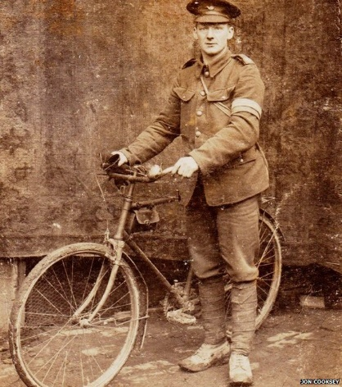
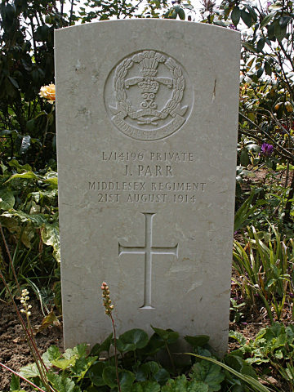
I was fourteen when I joined the army in 1912. I lied about my age, along with quarter of a million other boys. Working as a caddie at the local golf course was OK, but it was nothing compared to the adventure that awaited me! Of course, Mum was very unhappy, even more so when war was declared in 1914.
By then, I was seventeen. Older. More mature. And excited about serving my country. My superiors said I was clean, sober and intelligent, but “Inclined to be subordinate.” Yes that’s me! A brown-haired, brown-eyed little rascal! At 5ft 3in I was not the tallest soldier, but I made up for that.
I left my home in north London with a spring in my step. My regiment, the Middlesex, set sail from Southampton to Boulogne-sur-Mer. Our aim was to stop the German army who were invading Belgium.
My role was a reconnaissance cyclist. This meant I passed on important messages to the commanding officers, such as the details of the positions and movement of enemy troops.
The memories are so vivid now as I look down. I was near the French border with Belgium in a village. I remember the German cavalry coming towards me; my bike no match for the speed of their horses. I remember going down, but I couldn’t tell you where the bullet came from. It could have even been one of the Allied soldiers. We were so young and on edge. None of us had been in that situation before. The reality was terrifying.
You may be thinking ‘why is his story so special?’ After all, 700,000 British soldiers died in the war. Well, I’m John Parr, the very first British soldier to be killed in World War One.
A hundred years on, people are still unsure how I was killed. But I was one of the lucky ones. I missed out on the trenches, poison gas and mechanised warfare. At least it was quick for me.
Fact file: Private John Parr
Born:
19th July 1897, Church End, England
Died:
21st August 1914, Obourg, Belgium
Parents:
Edward Parr (Milkman) & Alice Parr
Service: British Army
Rank: Private
Unit:
4th Battalion, Middlesex Regiment
A reconnaissance cyclist

Questions – A Tale of Two Soldiers: Private John Parr
1) How many boys lied about their age to get into the army? (1) ___________________
2) How did John Parr’s Mum feel about him joining the army? (1) _________________
3) What job was he doing before he signed up? (1) ____________________________
4) Complete the following information about John Parr at the outbreak of war: (8)
Height
Age
Eye colour
Hair colour
Positive comments from superiors
Negative comments from superiors

5) What was John Parr’s role in the war? (1) ________________________________
6) What was the aim of his regiment? (1) __________________________________
7) Why might John Parr have been killed by one of the Allied soldiers? (2)
______________________________________________________________________________________________________________________________
8) Why does he describe himself as ‘one of the lucky ones’? (3)
______________________________________________________________________________________________________________________________
9) ‘The memories are so vivid now as I look down’. What does Private John Parr mean by ‘as I look down’? (2)
______________________________________________________________________________________________________________________________
10) What did his father do for a living? (1)__________________________________
11) The official cemetery records show the age at his death to be 20. Why might this be? (1)
_______________________________________________________________
CHALLENGE: What do the following words from the text mean?
reconnaissance vivid superiors cavalry subordinate

Answers – A Tale of Two Soldiers: Private John Parr
1) How many boys lied about their age to get into the army? (1)
A quarter of a million
2) How did John Parr’s Mum feel about him joining the army? (1)
Unhappy
3) What job was he doing before he signed up? (1)
A caddie at the golf course
4) Complete the following information about John Parr at the outbreak of war: (8)
Height | 5ft 3 inches
Age | 17
Eye colour | Brown
Hair colour | Brown
Positive comments from superiors | - Clean  - Sober  - Intelligent
Negative comments from superiors | Inclined to be subordinate

5) What was John Parr’s role in the war? (1)
Reconnaissance cyclist
6) What was the aim of his regiment? (1)
To stop the German army.
7) Why might John Parr have been killed by one of the Allied soldiers? (2)
They were young and on edge; one of them had been in that situation before.
8) Why does he describe himself as ‘one of the lucky ones’? (3)
He avoided the trenches, poison gas and mechanised warfare
9) ‘The memories are so vivid now as I look down’. What does Private John Parr mean by ‘as I look down’? (2)
He had been killed and was looking down from heaven.
10) What did his father do for a living? (1)
Milkman
11) The official cemetery records show the age at his death to be 20. Why might this be? (1)
He had lied to get into the army, so official records show his age to be 20 instead of 17.
CHALLENGE: What do the following words from the text mean?
reconnaissance vivid superiors cavalry subordinate
Use a dictionary to check answers

