History Focus | WW1 | Year 6 | Autumn 1
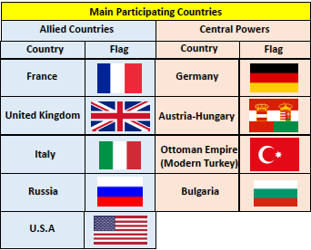
When? (Key Knowledge)
June 1914 | Archduke Franz Ferdinand of Austria is assassinated by a Serbian terrorist.
June 1914 | Following a number of threats, Austria-Hungary declares war on Serbia.
August 1914 | Germany declares war on Russia in support of Austria- Hungary before declaring war on France. Following a German invasion of Belgium, Britain declares war on Germany.
September 1914 | The German army is stopped short of Paris by British and French soldiers. Trench warfare begins.
April 1917 | America declares war on  Germany.
November  1918 | Armistice agrees that sees Germany admit defeat. Guns fall silent at 11am.

Diagrams and Symbols
Background Information
World War I began in 1914, after the assassination of Archduke Franz Ferdinand, and lasted until 1918. During the conflict, Germany, Austria-Hungary, Bulgaria and the Ottoman Empire fought against Great Britain, France, Russia, Italy, Romania, Japan and the United States. Thanks to new military technologies and the horrors of trench warfare, World War I saw unprecedented levels of carnage and destruction. By the time the war was over, more than 16 million people (soldiers and civilians) were dead.

What? (Key vocab)
Spelling | Definition
Allied Powers | An alliance between a number of countries including Britain, France, Russia, Italy, and Japan.
Balkans | A region in Southeast Europe that includes countries such as Bulgaria, Croatia, Greece, and Romania.
Conscript | A person who is enlisted into the army whether they want to join or not.
Dreadnought | Dreadnoughts were large and heavily armoured battleships.
Frontline | The front line was the point at which the armies of each side met. This is where most of the fighting took place.
Propaganda | Information used and distributed to present one side of an issue.
Treaty of Versailles | The Treaty between the Allies and Germany that ended World War I.

Who?
Winston Churchill | - On the war council during WWI; later because prime minister during WWII.
Woodrow Wilson | - President of the United States during the war.

