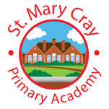

Writing Curriculum
Year 6
Autumn 1 | Autumn 2 | Spring 1 | Spring 2 | Summer 1 | Summer 2
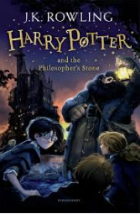 | 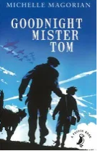  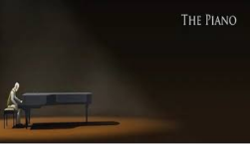 | 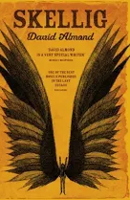  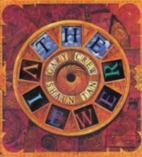 |   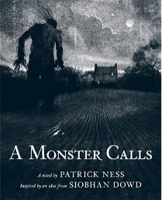 | 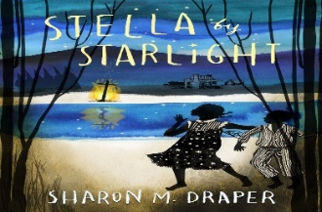 | 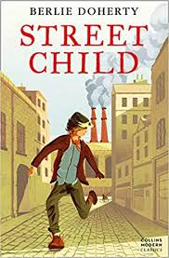
Genre & Plot Structure:  Fantasy | Genre & Plot Structure:  Historical Fiction | Genre & Plot Structure:  Mystery | Genre & Plot Structure:  Fiction – Environmental  Magical Realism | Genre & Plot Structure:  Global issues - fiction | Genre & Plot Structure:  Historical Fiction
Outcomes:  - Character description  - Acceptance Letter  - Persuasive argument  - Poetry  - NCR – Fantastic Beasts  - Setting Description of The Great Hall/Feast  - Newspaper Reports Gringott’s Break-in | Outcomes:  The Piano  - Emotional Letter  - Flashback  GNMT  - Persuasive argument  - Diary Entry  - Balanced argument  - Narrative  - Narrative Recount | Outcomes:  The Viewer  - Describing Images  - Narrative ending  Skellig  - Evolution Leaflets  - Setting description  - Poem | Outcomes:  A Monster Calls  Writing outcomes:  - Formal and informal letter  - Setting descriptive  - Suspense narrative  - Character description through an obituary  Varmints  - Settings (changing the atmosphere)  - Balanced argument | Outcomes:  Stella  - Recount from Stella’s POV on the night they see the KKK  - Editorial piece for newspaper | Outcomes:  - Diary Entry  - Instructional writing – humorous (writing for entertainment  - Newspaper Report
Grammar &  Composition  - Bullet Points  - Colon to introduce a list  - Speech Punctuation  - Concise Expanded Noun Phrases  - Passive voice  - Topic Sentences and paragraph use in NF  - Dash  - Hyphen  - Successful editing | Grammar &  Composition  1. Colon to separate clauses.  2. Variety of sentence structure  3. Create cohesion  4. Speech Punctuation  5. Concise Expanded Noun Phrases  6. Passive voice  7. Dash  8. Hyphen  9. Editing content effectively | Grammar &  Composition  1. Semi-colon to separate clauses.  2. Variety of sentence structure  3. Create cohesion  4. Speech Punctuation  5. Concise Expanded Noun Phrases  6. Passive voice  7. Dash  8. Hyphen  9. Synonyms  10. Powerful vocabulary (especially verbs) | Grammar &  Composition  Whole of Y6 Writing framework will be covered within the 3 writing outcomes for this unit  - Formality / informality  - Use of concise descriptive language  - Structure and grammar manipulation to create effect (particularly suspense)  - Language choices to express shift in atmosphere | Grammar &  Composition  Whole of Y6 Writing framework will be covered within the writing outcomes for this unit. | Grammar &  Composition  Whole of Y6 Writing framework will be covered within the 3 writing outcomes for this unit  - Carefully chosen effective use of verbs and adverbs  - How to create humour  - Manipulating language for effect (as a character’s accent/colloquialisms)  - Adapting spoken language to written.

