

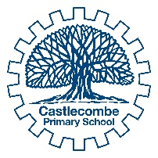
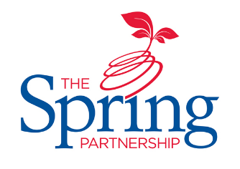
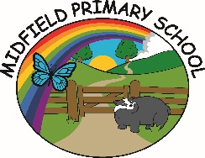

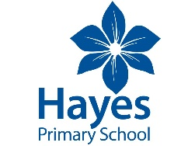
The Spring Partnership Trust

Home Learning Overview:
Year |Group: 3 Week Beginning: 4th January 2021
Subject | For week beginning:
Subject | - Resources needed | - Guidance (Part of home learning)
English | https://www.youtube.com/watch?v=_BjIO0lwrcY  You tube link to the Year 3 text Ug: Boy Genius of the Stone Age read by Mr Kay.  There are 5 parts, your child will need to watch all 5 parts on Day 3: Wednesday 6th January | Each English lesson is explained on the power point on the school website. This is the link:  https://www.st-marycray.bromley.sch.uk/page/?title=Week+1+w%2Fb+4+January&pid=496&action=saved  The tasks sheets are on the link below, these can be saved and sent to the teacher via class dojo. This is the link:  https://www.st-marycray.bromley.sch.uk/page/?title=Week+1+w%2Fb+4+January&pid=496&action=saved
Guided Reading  Mon - Thurs | https://www.st-marycray.bromley.sch.uk/page/?title=Week+1+w%2Fb+4+January&pid=496  Above is the link to the Guided reading tasks on the SMCPA website.  https://www.youtube.com/watch?v=_BjIO0lwrcY  Above is the link to the first part of Ug: Boy Genius of the Stone age: Part 1 Read by Mr Kay. | Watch the You Tube video opposite.  Answer the questions for each day save and send back to Mrs Fenton or Mrs Richards on Class Dojo.
Spelling | https://www.st-marycray.bromley.sch.uk/_site/data/attachments/P496/Clued-Spelling-Sets.221267356.pdf | Your child should continue to learn the spellings from their clued spelling set. Please encourage them to learn 5 words per week.  If your child can not remember which set they are learning please let us know and we will pop into school to find out.
Grammar | https://www.youtube.com/watch?v=9hsPNjEMOJ0 | Paragraphing – grouping  Watch the video and complete the task below about paragraphs  https://www.st-marycray.bromley.sch.uk/page/?title=Week+1+w%2Fb+4+January&pid=496
Maths | Videos on the White Rose Maths website  Worksheets on our class page on the website. | https://whiterosemaths.com/homelearning/year-3  Follow the lessons on White Rose website. Watch the videos then complete the worksheets. All worksheets can be found on the school website below:  https://www.st-marycray.bromley.sch.uk/page/?title=Week+1+w%2Fb+4+January&pid=496&action=saved
Times tables | Try  www.mathschase.com  Fun games to practise… | Mild: learn the 2 times table  Spicy: learn the 4 times table  Hot: learn the 8 times table  Use the online games opposite, copy them, sing them, ask your parents or older siblings to test you.
Science | BBC Bitesize | WALT: recognise that we need light in order to see things and that dark is the absence of light.  https://www.bbc.co.uk/bitesize/topics/zbssgk7/articles/z2s4xfr  Watch the video and complete the task and quiz below.  Children to draw and label as many different light sources as they can think of.
Geography | https://www.st-marycray.bromley.sch.uk/_site/data/attachments/P496/Yr3-Geog-Lesson-1-resource.219591482.221241825.pdf | WALT: Locate Mexico and identify key features  Children to complete the fact page about Mexico using an Atlas and links below  https://www.youtube.com/watch?v=9bil9E5wdaY – video  https://www.youtube.com/watch?v=m2U6Hj0FaYA&feature=emb_logo - video  https://www.kids-world-travel-guide.com/mexico-facts.html -  https://kids.nationalgeographic.com/explore/countries/mexico/
Art | Paper  Pens or pencils | 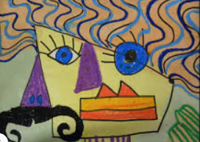  WALT: To create images for a collage from experience, observation and imagination.  Introduce the children to the artist Pablo Picasso.  https://www.bbc.co.uk/bitesize/clips/zdfgkqt  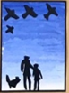  Children to draw a portrait in the style of Picasso  https://www.youtube.com/watch?v=wrXmE6XYbYw
PSHE |  | WALT identify people who have faced difficult challenges and achieved success  Children to complete the comprehension on Tanni Grey-Thompson.  https://www.st-marycray.bromley.sch.uk/_site/data/attachments/P496/Yr-3-PSHE-lesson-1-comprehension.219591482.221241524.pdf
Discovery RE | paper | WALT explain how we can deal with illness  Read the story: ‘Bear Feels Sick’ by Karma Wilson discuss what happened to Bear and how he felt better. https://www.youtube.com/watch?v=L26huJs7yq4  Children to write a remedy/recipe using natural ingredients to make Bear feel better.
Music |  | WALT identify patterns in music  Explore creating different sounds and changing the pitch and tempo on song lab option  https://musiclab.chromeexperiments.com/
PE | https://www.youtube.com/watch?v=EHGi-_4jAIk  https://www.youtube.com/watch?v=X655B4ISakg | Take part in a Joe Wicks PE session  Take part in a Yoga for kids session with Sophia

