Task 1:
Imagine an alien arrives from outer space! How would you explain ‘bullying’ to them? Give one example to help the alien`s understanding.
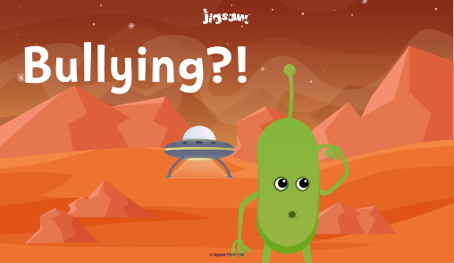
Task 2:
Read the 6 scenarios below. For each scenario, talk in your pairs about whether you think it is bullying or not, and suggest what the characters could do the prevent the situation from happening in the future.
1. Sarah and Ben are playing football. Yussef asks if he can play but Ben says, “No, we’ve already picked our teams, you can’t play.” Yussef then grabs the ball and runs away with it, spoiling their game.
2. Sally and Jemma are skipping. Sally accidentally trips Jemma up. Jemma shouts at her, “You idiot! Watch what you are doing!” Sally is upset as she hadn’t meant to do it and runs away from the game.
3. Mark pushes into the line knocking into Simion into the wall. “Watch out, you gay”, Simion shouts and pushes Mark.
5. Flora won’t let Emily join in the dance competition and says to Emily, “You’re fat; we don’t want you on our team.”
4. Lily is always calling Lee names. She waits for him at playtime and after school, taunting him and saying mean things about his family and his clothes. Lee doesn’t understand why she is so mean to him.
6. Martin tells Stella and Levi to look at a video on YouTube that he knows will scare them and give them nightmares.


