
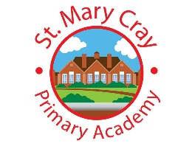
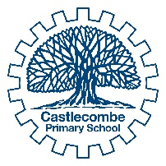
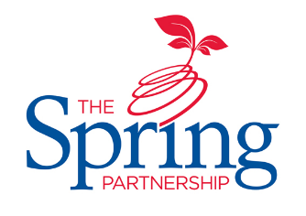


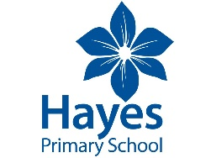
The Spring Partnership Trust

Home Learning Overview:
Year |Group: 3 Week Beginning: Monday 14th December
Subject | For week beginning:
Subject | - Resources needed | - Guidance (Part of home learning)
English | Oak Academy | https://classroom.thenational.academy/units/christianity-90fd  Please follow the link for 10 lessons (2 per day) concerning Christianity.
Reading | Reading Book | Reading should happen daily for 30 minutes.
Spelling | Spelling Sets – on school website. | Your child should continue to learn the spellings from their clued spelling, spelling set.
Grammar | Assessment questions | Please complete the assessment questions for …....... saved on the school website.
Maths | Videos on the White Rose Maths website  Worksheets on our class page on the website. | https://whiterosemaths.com/homelearning/year-3  Follow the lessons on White Rose website. Watch the videos then complete the worksheets. All worksheets can be found on the class pages on the school website.
Times tables | PIXL App | Practice your times tables on the PIXL TT App
Science | Knowledge Organiser  Assessment Questions | Please find the Forces and Magnets Knowledge Organiser and Assessment Questions saved on the school website. Research and revise using the organiser, and then see how much you have remembered about this half-term`s topic by having a go at the questions.
History | Knowledge Organiser  Assessment Questions | Please find the Shang Dynasty Knowledge Organiser and Assessment Questions saved on the school website. Research and revise using the organiser, and then see how much you have remembered about this half-term`s topic by having a go at the questions.
Art/ D &T | Paints | Window diary!  Look out of your window every day and keep a ‘diary’ of what the sky looks like in picture form. Can you use a different medium every day? (Monday = paint, Tuesday = pastels etc). Try and use you colour mixing to show the emotion of the sky.
PSHE | n/a | WALT: identify different ways of showing appreciation for my friends and classmates  Please complete PHSE Week 6 resource saved on the school website.
Discovery RE | Knowledge Organiser  Assessment Questions | Please find the Christianity: Christmas Knowledge Organiser and Assessment Questions saved on the school website. Research and revise using the organiser, and then see how much you have remembered about this half-term`s topic by having a go at the questions.

