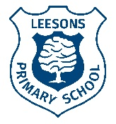
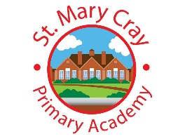

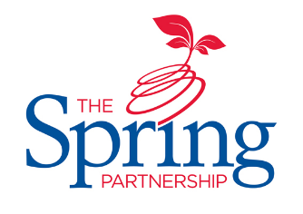
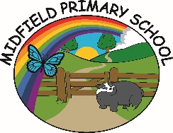

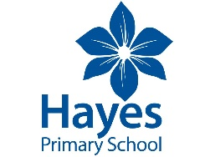
The Spring Partnership Trust

Home Learning Overview:
Year |Group: 3 Week Beginning: Monday 30th November
Subject | For week beginning:
Subject | - Resources needed | - Guidance (Part of home learning)
English | Oak Academy | Follow the link to 6 activities to enable us to write our own instructions – we need Lessons 1,4, 5, 6, 8 and 9.  https://classroom.thenational.academy/units/monster-pizza-instructions-9061
Reading | Reading Book | Reading should happen daily for 30 minutes.
Spelling | Spelling Sets – on school website. | Your child should continue to learn the spellings from their clued spelling, spelling set.
Grammar | BBC Bitesize | Please complete the …………………. questions saved on the school website.
Maths | Videos on the White Rose Maths website  Worksheets on our class page on the website. | https://whiterosemaths.com/homelearning/year-3  Follow the lessons on White Rose website. Watch the videos then complete the worksheets. All worksheets can be found on the class pages on the school website.
Times tables | PIXL App | Practice your times tables on the PIXL TT App
Science |  | WALT: understand magnetic attraction  https://classroom.thenational.academy/units/magnetism-084a  Please complete Lessons 5 and 6
History | PPT | WALT: research an element of Shang life.  Look at the two websites https://sites.google.com/wwrsd.org/socialstudies7/becivilized/03-shang-shadows/epic-quest-shang-museum or https://classroom.thenational.academy/units/the-shang-dynasty-75f2.  Can you design a fact-file about the area of Shang life that interests you the most?
Art/ D &T | Paints | 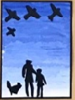  WALT: colour mix  Experiment with colour mixing using paint. Using https://www.youtube.com/watch?v=lLYlLvOws5E , can you paint your own nativity scene using oil pastels?
PSHE | n/a | WALT: understand the role of witnesses if bullying occurs  Please complete the task sheet saved on the school website.
Discovery RE | n/a | WALT: understand the relevance of Christmas  Please complete the comprehension saved on the school website.

