


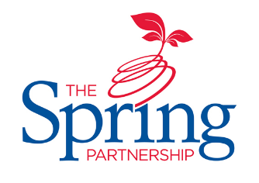



The Spring Partnership Trust

Home Learning Overview:
Year Group: 3 Week Beginning: Monday 9th November
Subject | For week beginning:
Subject | - Resources needed | - Guidance (Part of home learning)
English | Oak Academy | https://classroom.thenational.academy/units/the-firework-makers-daughter-by-phillip-pullman-95e6 Follow the link to 5 activities based around the Firework Maker`s Daughter by Phillip Pullman.
Reading | Reading Book | Reading should happen daily for 30 minutes.
Spelling | Spelling Sets – on school website. | Your child should continue to learn the spellings from their clued spelling, spelling set.
Grammar | BBC Bitesize | Watch the video about using commas in a list https://www.bbc.co.uk/bitesize/articles/zh7bgwx and complete the activities.
Maths | Videos on the White Rose Maths website  Worksheets on our class page on the website. | https://whiterosemaths.com/homelearning/year-3  Follow the lessons on White Rose website. Watch the videos then complete the worksheets. All worksheets can be found on the class pages on the school website.
Times tables | PIXL App | Practice your times tables on the PIXL TT App
Science | BBC Bitesize | WALT: understand friction  https://www.bbc.co.uk/bitesize/clips/zht2tfr Watch the clip; what message does it give about experiments and friction? Using only toys cars, a slide and a variety of different materials, can you plan and perform an experiment that judges what material will let a toy car slide down it quickest!
History | PPT | WALT: understand when the Shang Dynasty occurred.  Using the PPT saved on our class webpage entitled ‘Shang Dynasty’, please create a timeline of the key events that occurred from 1600 BC to 1046 BC.
Art/ D &T | Paints | 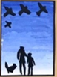  WALT: colour mix.  Experiment with colour mixing using paint. Can you mix colours to produce a brand new colour? What would you call it? Mix three colours together but don`t show your parent/carer; can they now recreate your colour?
PSHE | n/a | WALT: understand the concept of family  Draw a family portrait and label each family member with a statement about what they mean to you.
Discovery RE | n/a | WALT: understand the relevance of Christmas  Watch this video: https://www.bbc.co.uk/teach/class-clips-video/religious-studies-KS2-christmas/z4xcjhv  Please make a note of all traditions that Christians have at Christmas. Which one is the most important and why?

