Ammonite  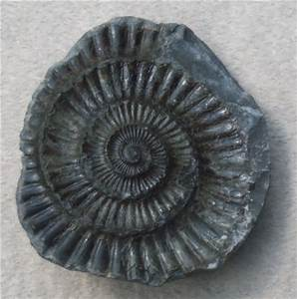  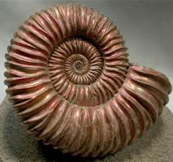  It had coiled shells (looks like snail shell) and used to float around in the ocean. Died out / extinct for about 70 million years ago. Appeared in the Cambrian Period. Families stayed together? | 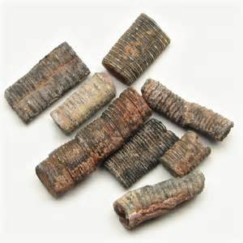  Crinoid Stem  They are found in North America and they attach themselves to the ocean floor. Appeared first in the Ordovician Period.
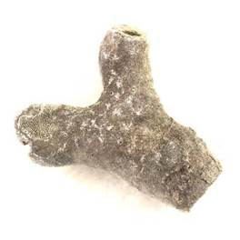  Bryozoa  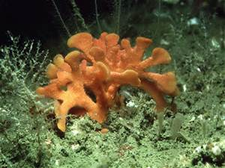  Looks similar to coral but they are more complex.  They have a shaped digestive tract which includes the mouth and the anus. First appeared in the Ordovician Period. | Colony Coral  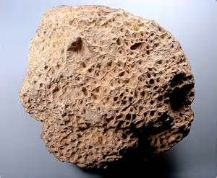  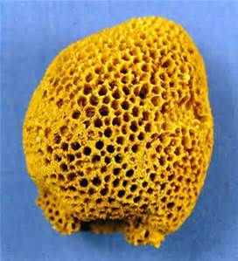  Masses of corals growing together first appeared in the Jurassic Period. Each hole in the coral had an individual animal called a polyp.
Petrified Wood  It is formed when water dissolves the real wood. It begins to fossilise when the water breaks off the outer wood on it.  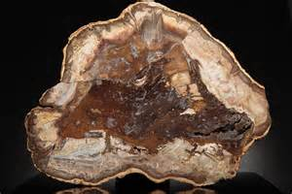 | 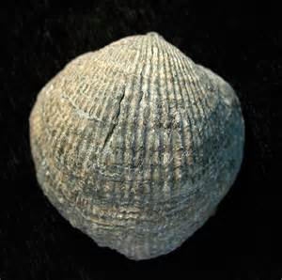  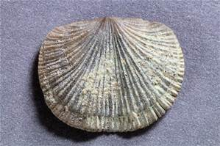  Brachiopod  They look like a tiny shell that may live on the sand and have originated / descended from shellfish. Approximately 30,000 different species.
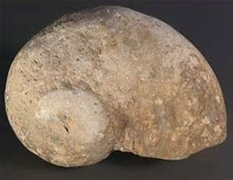  Gastropod  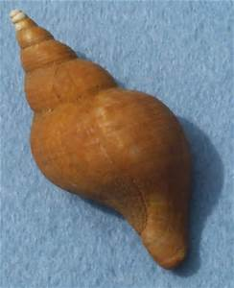  Animals that crawled around without any legs. They have one foot (tentacle) eyes and a tongue called a radula. They first appeared in the late Cambodian Period. May be a relative of sea snail because of its coiled spiralling shell. | 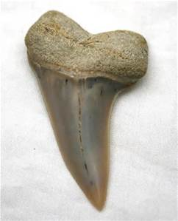  Shark’s tooth  Sharks have been around for about 40 million years. They first appeared in the Devonian Period. They are mostly made of cartilage.
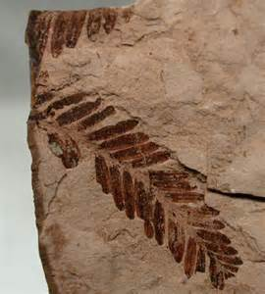
Fossil plant matter
Blue/green algae fossils that have been around for 3.4 million years old. First appeared in the Devonian period. The fern fossils were the first plant fossil ever. It looks like different leaves that we see today.

