


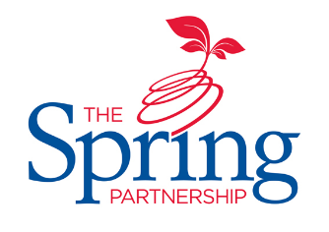



The Spring Partnership Trust

Home Learning Overview:
Year |Group: 6 Week Beginning: Monday 14th December
Subject | For week beginning:
Subject | - Resources needed | - Guidance (Part of home learning)
English

Reading | Book | Reading should happen daily for 30 minutes.
Spelling | Spelling Sets – on Midfield website | Your child should continue to learn the spellings from their clued spelling, spelling set.
Grammar | BBC Bitesize | Focus: Parenthesis
Maths | Videos on the White Rose Maths website  Worksheets on our class page on the website. | Follow the lessons on White Rose website. Watch the videos then complete the worksheets.  https://whiterosemaths.com/homelearning/year-6  All worksheets can be found on the class pages on the school website.
Times tables | PIXL App | Practice your times tables on the PIXL TT App
Science | BBC Bitesize | Revision  Use this page on BBC Bitesize to revise all your learning for The Human Body – scroll down to Human body. Take the quizzes to check your knowledge!
History | BBC Bitesize | WALT: investigate the end of WW1  Discover what brought WWI to an end by using this page. Then, compare Europe in 1914 and 1920. What are similarities and differences? Record your findings in a table.
Art/ D &T | Paints (red, blue, yellow, white and black – for mixing colours)  Brush  Paper | WALT: use pointillism and colour mixing techniques to create a piece of art  Completing the piece of art from last week’s lesson – adding detail using the techniques learnt over this term.
PSHE | YouTube  Paper & Coloured pencils | WALT: understand that differences can be a source of conflict or a cause for celebration  Watch this video about the Equality Act. Differences can be a source of conflict or a reason for celebration. Use a comic strip to create a story line that shows either that a difference is a source of conflict or a reason for celebration and how people react to that.
RE | End of unit quiz from the class page on the website | WALT: understand why we celebrate significant events  Thinking about those who celebrate Christmas, evaluate why we celebrate events. Is it only if we are of that religion? Make a list of all the celebration – religious or otherwise – that you can think of. Sort them into a table with the headings ‘celebrating a past event’ and ‘celebrating something new’.  Complete end of unit quiz.

