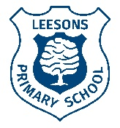
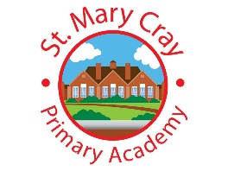
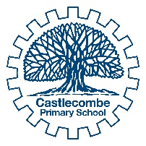
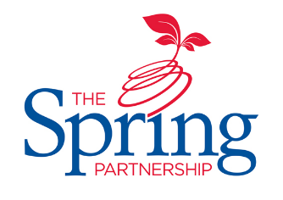
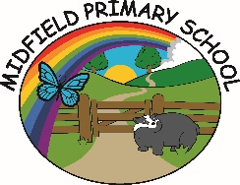

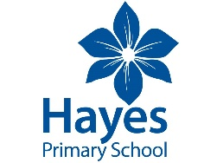
The Spring Partnership Trust

Home Learning Overview:
Year |Group: 6 Week Beginning: Monday 7th December
Subject | For week beginning:
Subject | - Resources needed | - Guidance (Part of home learning)
English | Goodnight Mr Tom | Write a poem describing some of the characters that live in Little Weirworld
Reading | Book | Reading should happen daily for 30 minutes.
Spelling | Spelling Sets – on Google classroom | Your child should continue to learn the spellings from their clued spelling, spelling set.
Grammar | BBC Bitesize | Focus: Passive Voice  Use the information on this page to find out about passive voice.  Complete the quiz to test your knowledge.
Maths | Videos on the White Rose Maths website  Worksheets on our class page on the website. | Follow the lessons on White Rose website. Watch the videos then complete the worksheets.  https://whiterosemaths.com/homelearning/year-6
Times tables | PIXL App | Practice your times tables on the PIXL TT App
Science | End of unit quiz – see class page on the website. | End of unit quiz  Complete the quiz to see if you’ve met all the objective for this term.  Use your knowledge organiser to revise any areas where you failed to answer the question correctly.
History | BBC Bitesize | WALT: explore life in Britain during WW1  Explores the public mood during WWI and how this was influenced by the government through propaganda. Use this page for information than create your own propaganda poster.
Art/ D &T | Paints (red, blue, yellow, white and black – for mixing colours)  Brush  Paper | WALT: use pointillism and colour mixing techniques to create a piece of art    Revise all the techniques for colour mixing that we have used so far this term. Use the techniques over two lessons, to create your own design. This lesson could be used for the background and outline with the detail coming in the second lesson.
PSHE | A device to access the internet for research | WALT: appreciate people for who they are  Research a Paralympic athlete/sportsperson. Find out about the life and achievements of your Paralympian and then design an AA (Admiration Accolade e.g. like an Oscar or an award) for them. Write a short presentation speech as if you were presenting the AA to your Paralympian.
RE | Paper for the collage  - This could be torn up magazines or other recyclables | WALT: recognise the symbolism attached to Mary  Revisit the key questions: How significant is it that Mary was Jesus’ mother? Focusing on the symbolism of Mary. What do you think a modern day Mary would look like? Why do you think this? Produce a portrait of a modern-day Mary using any medium you like – maybe try collage!

