


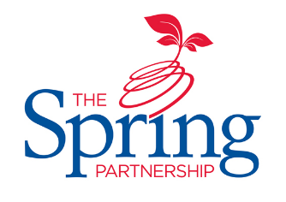



The Spring Partnership Trust

Home Learning Overview:
Year |Group: 6 Week Beginning: Monday 16th November
Subject | For week beginning:
Subject | - Resources needed | - Guidance (Part of home learning)
English | Goodnight Mr Tom chapter one | Have a look at the first chapter of Goodnight Mr Tom. Where have dashes and hyphens been used? What is the difference between the two? How could you use dashes or hyphens effectively in a diary entry? Write your own as if you are Willie explaining how he is feeling to arrive at Mr Tom’s.
Reading | Book | Reading should happen daily for 30 minutes.
Spelling | Spelling Sets – on Midfield website | Your child should continue to learn the spellings from their clued spelling, spelling set.
Grammar | BBC Bitesize | Focus: types of clause (main and subordinate)  Watch this video than construct 3 sentences containing a main clause and a subordinate clause. Watch out for this type of sentence in your reading this week!
Maths | Videos on the White Rose Maths website  Worksheets on our class page on the website. | Follow the lessons on White Rose website. Watch the videos then complete the worksheets.  https://whiterosemaths.com/homelearning/year-6  All worksheets can be found on the class pages on the school website.
Times tables | PIXL App | Practice your times tables on the PIXL TT App
Science | BBC Bitesize | WALT: build and use electrical circuits  Click here to find out what circuits are and how you can change them by adding items like switches and batteries.
History | BBC Bitesize | WALT: investigate what life was like on the western front  Learn all about life in the trenches from this page then write a letter home from a soldier on the Western Front, describing the living conditions.
Art/ D &T | Youtube  Paints (red, blue, yellow, white and black)  Brush | 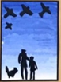  WALT: mix tints and shades  Learn about colour theory about the colour wheel here. Watch up to 2m25s. If you have paints, mix the hues (colours) with each other and black and white to create your own colour wheel.
PSHE | BBC Bitesize | WALT: understand how being different could affect someone’s life  Everyone is different but how does that affect us? Find out about how people cope with being different here.
RE | n/a | WALT: understand the significance of Mary as Jesus’ mother  Look at different depictions of Mary in art. What do we learn about her? Why do think she was painted in these specific ways?

