


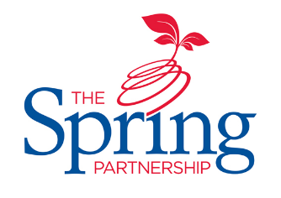



The Spring Partnership Trust

Home Learning Overview:
Year |Group: 6 Week Beginning: Monday 30th November
Subject | For week beginning:
Subject | - Resources needed | - Guidance (Part of home learning)
English

Reading | Book | Reading should happen daily for 30 minutes.
Spelling | Spelling Sets – on Midfield website | Your child should continue to learn the spellings from their clued spelling, spelling set.
Grammar | BBC Bitesize | Focus: Hyphens  Watch the video and complete the quiz.
Maths | Videos on the White Rose Maths website  Worksheets on our class page on the website. | Follow the lessons on White Rose website. Watch the videos then complete the worksheets.  https://whiterosemaths.com/homelearning/year-6  All worksheets can be found on the class pages on the school website.
Times tables | PIXL App | Practice your times tables on the PIXL TT App
Science | Access to the internet | WALT : research the work of significant scientists  Research one of the significant scientists in this unit, then present a profile, video presentation, poster or biography of the scientist.  You could create a mini-quiz on your famous scientist and your family!  Significant scientists: Thomas Edison (1847-1931). Inventor of the fuse.  Benjamin Franklin (1706-90). Showed that lightning is caused by electricity.  Alessandro Volta (1745-1827). Invented the first battery.  Or choose one of your own!
History | BBC Bitesize | WALT: explore the involvement of animals in WWI  Read the information on this page and then create a table to show the advantages and disadvantage. Explain how you think the war would have been different without these animals. What would have been easier/more difficult?
Art/ D &T | PPT from the class page on the school website. | WALT: explore the technique of pointillism  Learn about pointillism from the PowerPoint and create a picture of a leaf using this technique.
PSHE | BBC Bitesize | WALT: develop range of strategies for managing my feelings  Watch this clip. Write a list of strategies you could use to cope with this situation.
RE | n/a | WALT: understand how Mary became Jesus’ mother.  Read the information on this page, watch the video and complete the quiz.

